Conceptual Block Diagram

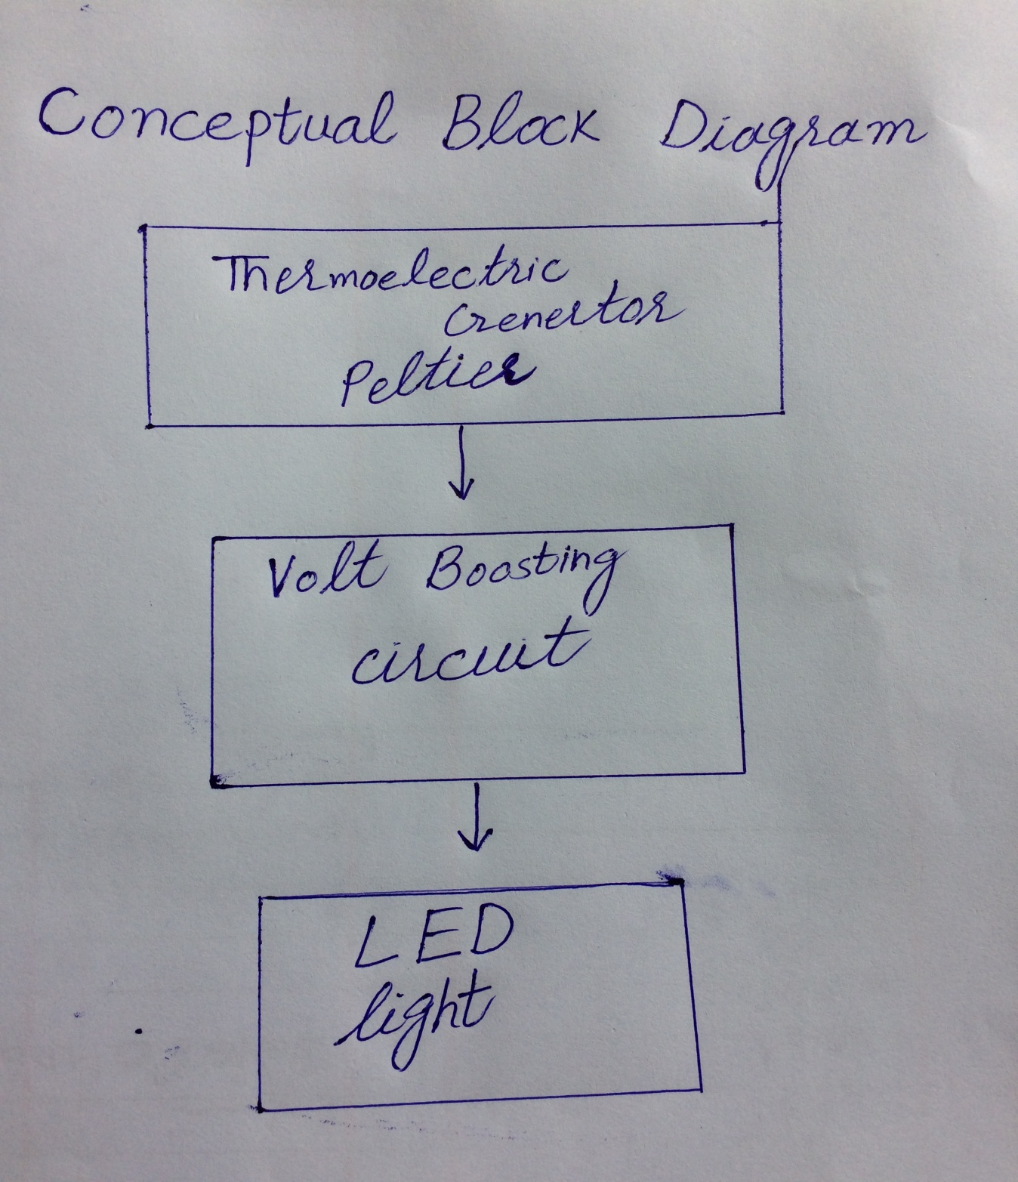
Secatch

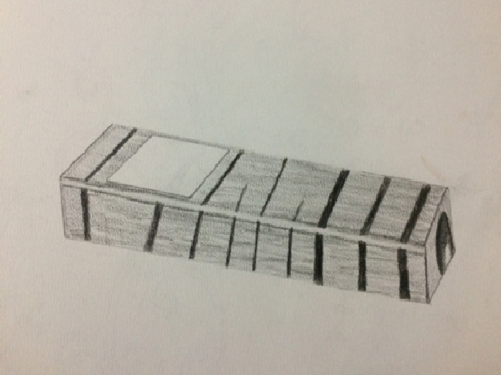
With Detail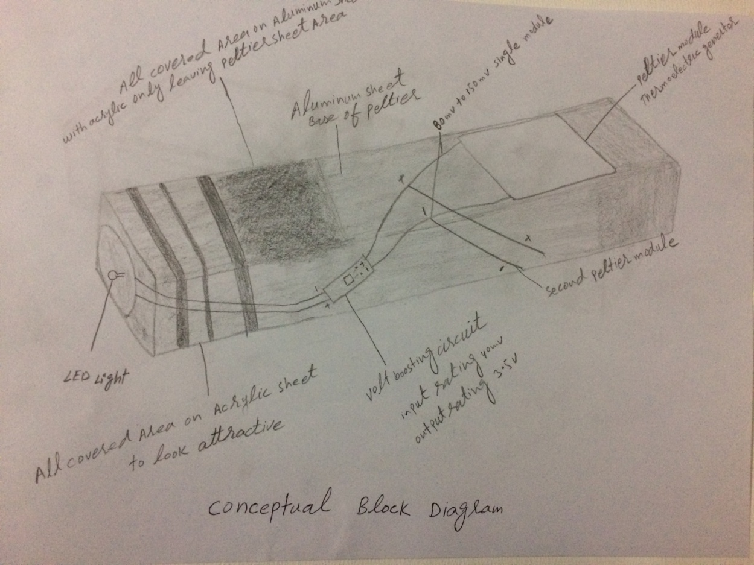
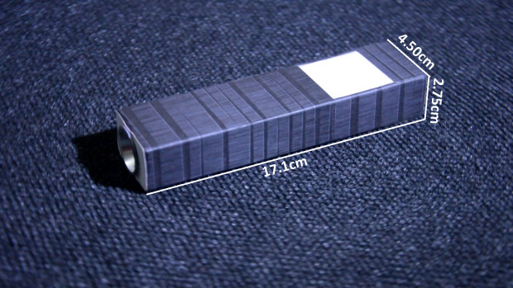Bill of Materials for Infinity
Name of materials used in flashlight
- (2)Thermoelectric generator peltier size 40mm 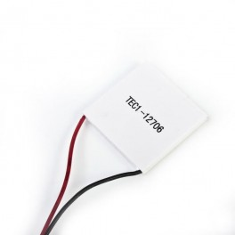
Link http://megaeshop.pk/tec1-12706-12v-6a-tec-thermoelectric-cooler-peltier-tec1-12706.html
- Unipolar Boost circuit convertor 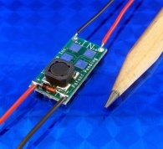
Link http://www.shop.customthermoelectric.com/ELC-VB0410-2-Bipolar-Boost-Converter-Circuit-ELC-VB0410-2.htm;jsessionid=F3561EC6FCA46551157931C1A71F520C.p3plqscsfapp001

LED 8mm 0.28W Strawhat White LED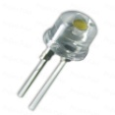 http://projectpoint.in/index.php?route=product/product&product_id=500188647086

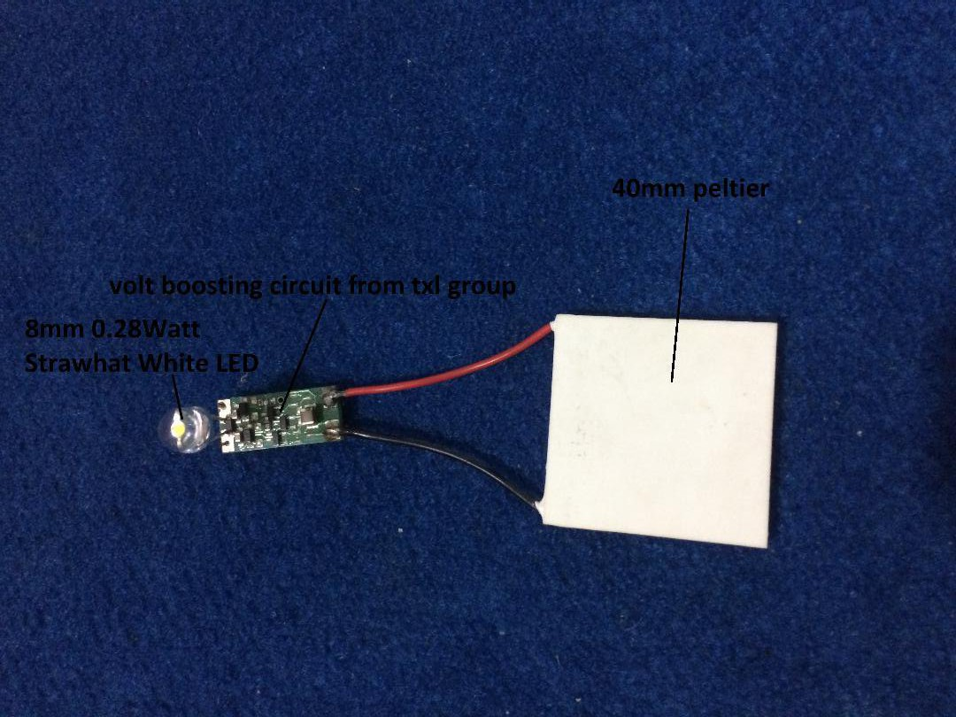
- Aluminum Rectangle pipe used for heat sink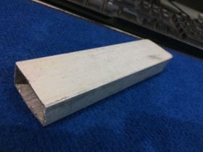
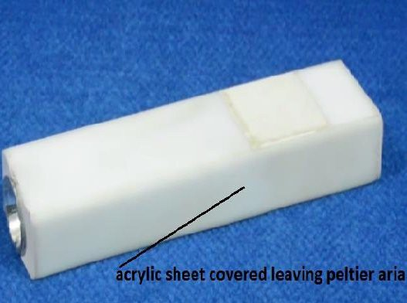
- Acrylic Sheet Covered on Aluminum pipe leaving aria of peltier 40mm local made
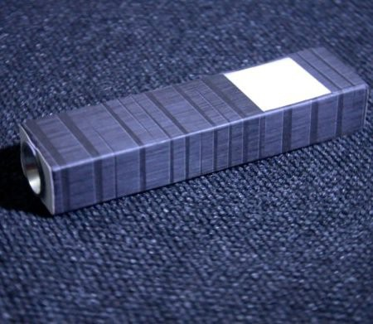
- Optional An Atrictive Sheet on Acrylic sheet leaving aria of peltier 40mm local made

Body Heat Powered Headlamp

Sectach

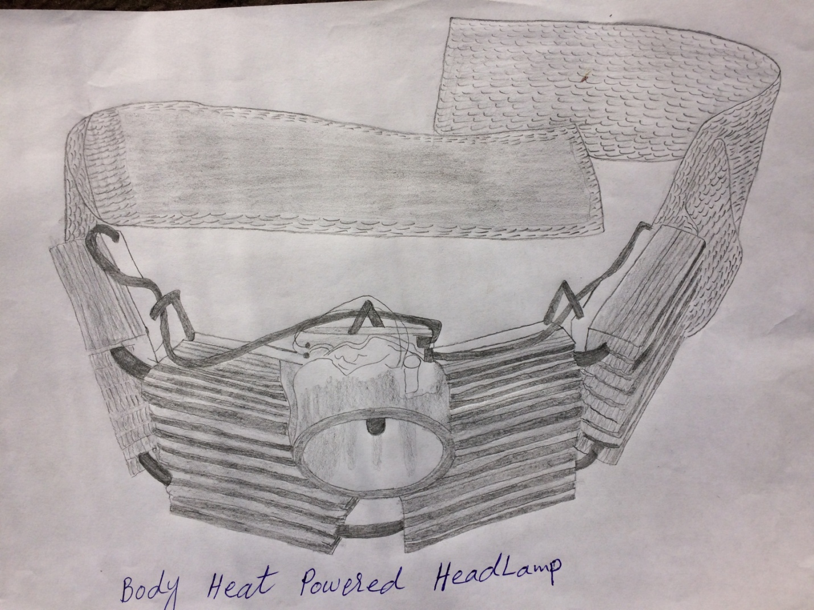

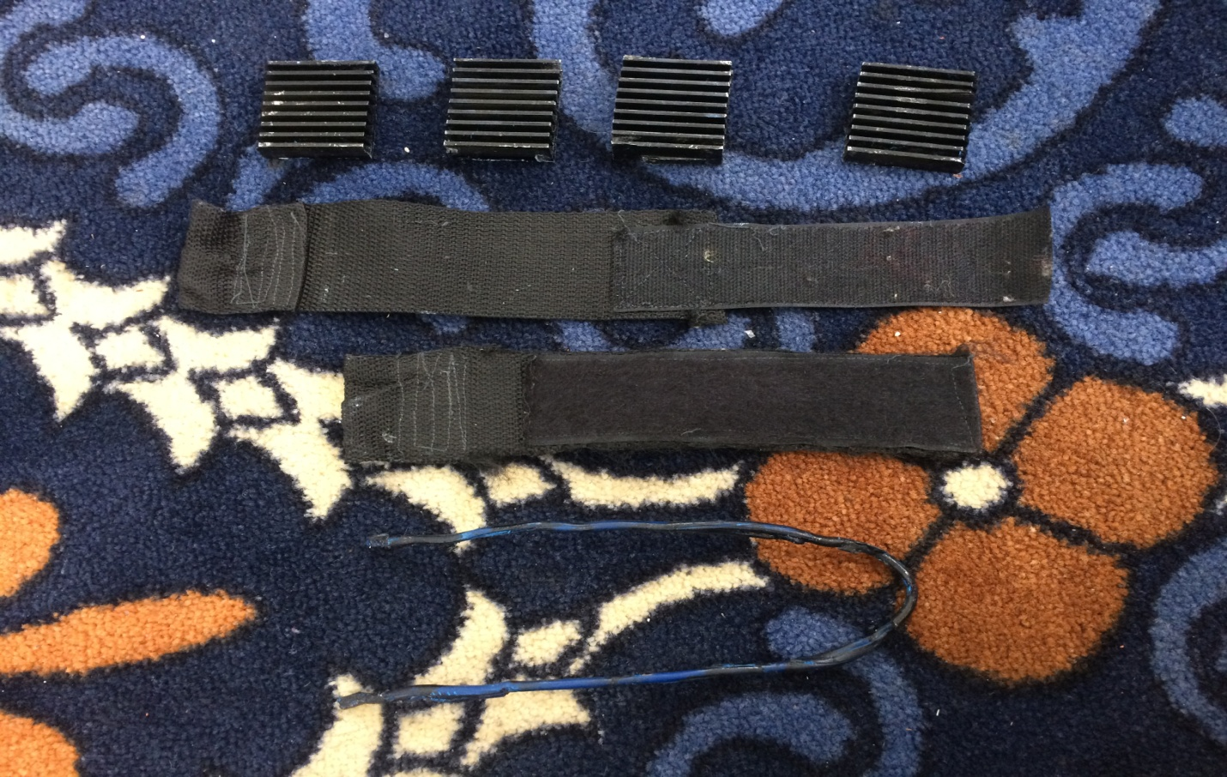

(4) Heat sink squire size 40.5mm
(2) Head raped strip
Hard wire 43 cm for connecting 4 heat sink
Fixing result
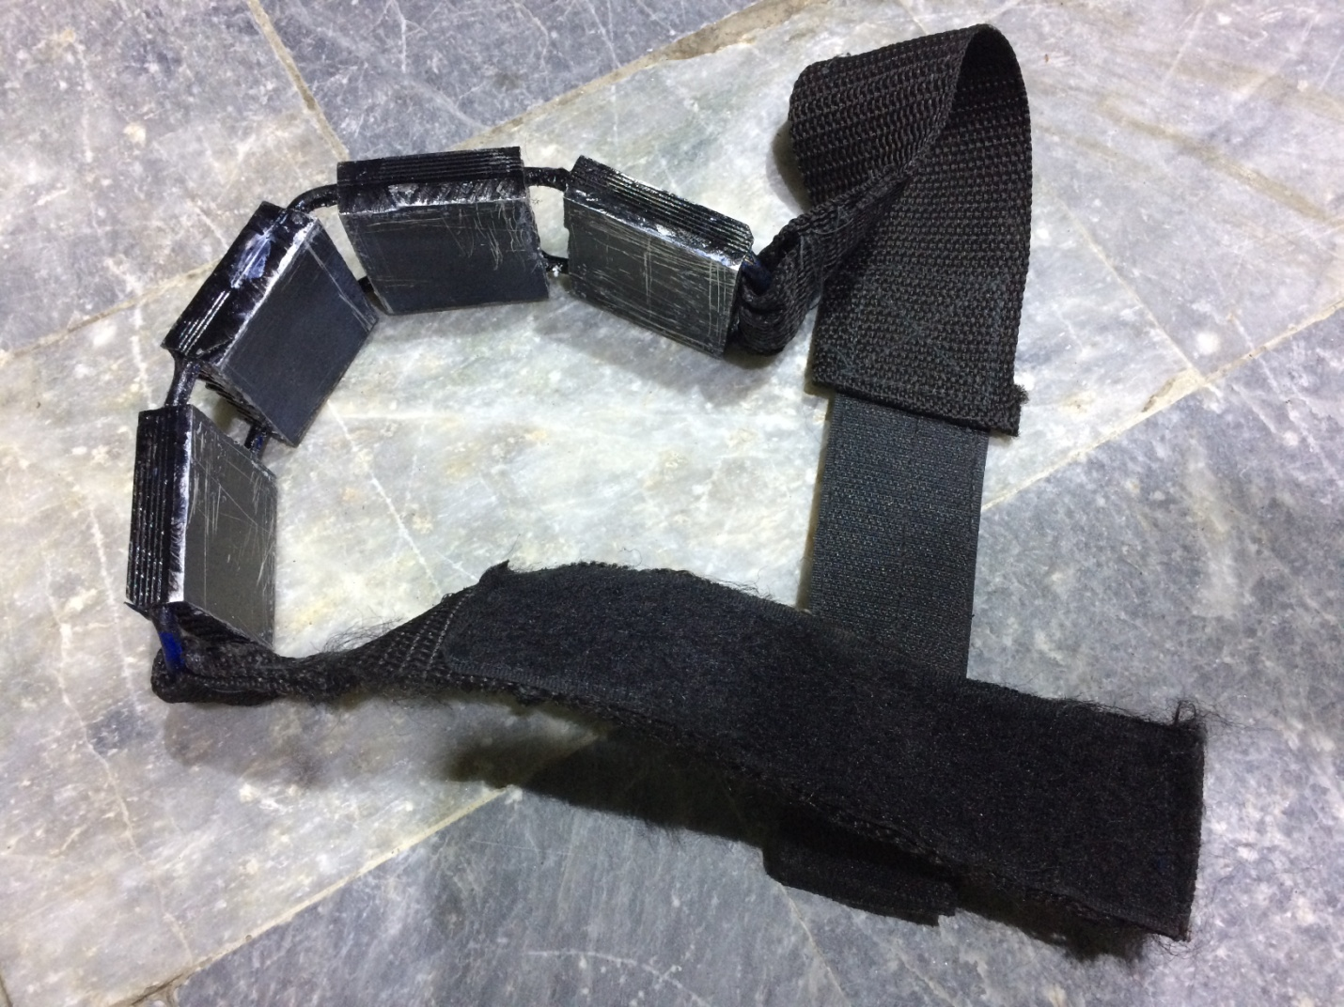

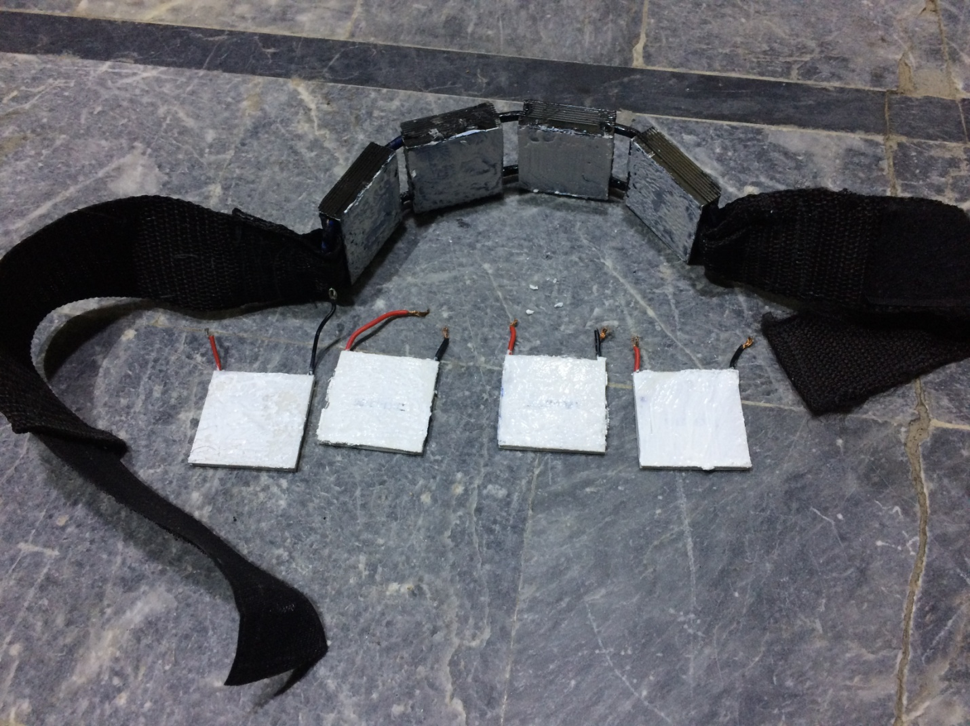
Thermal past local used on peltiers and heat sink

- (4)Thermoelectric generator peltier size 40mm
Link http://megaeshop.pk/tec1-12706-12v-6a-tec-thermoelectric-cooler-peltier-tec1-12706.html

Fixing peltiers on Heat sink
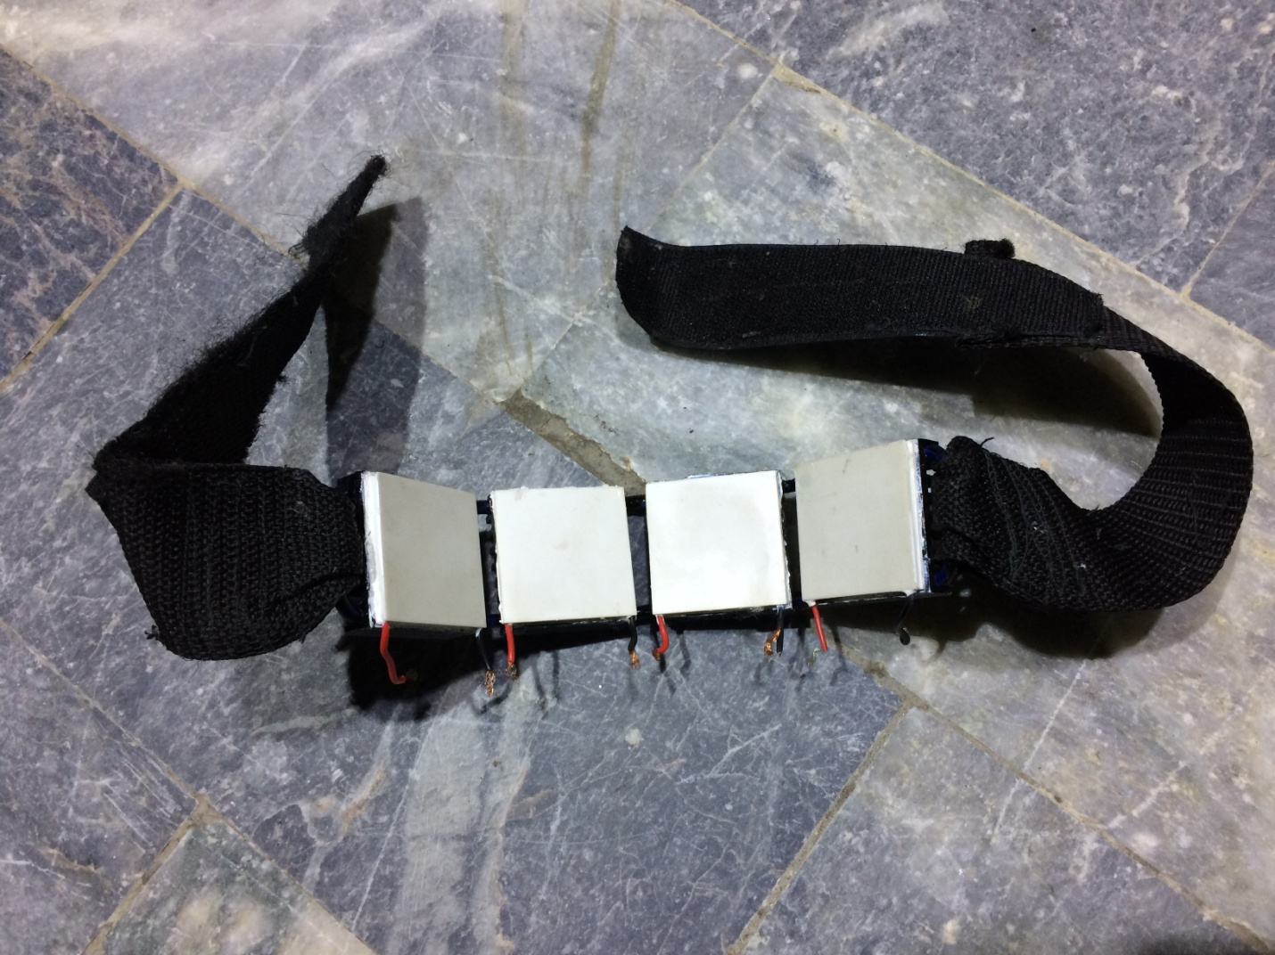

Making Series of Peltiers
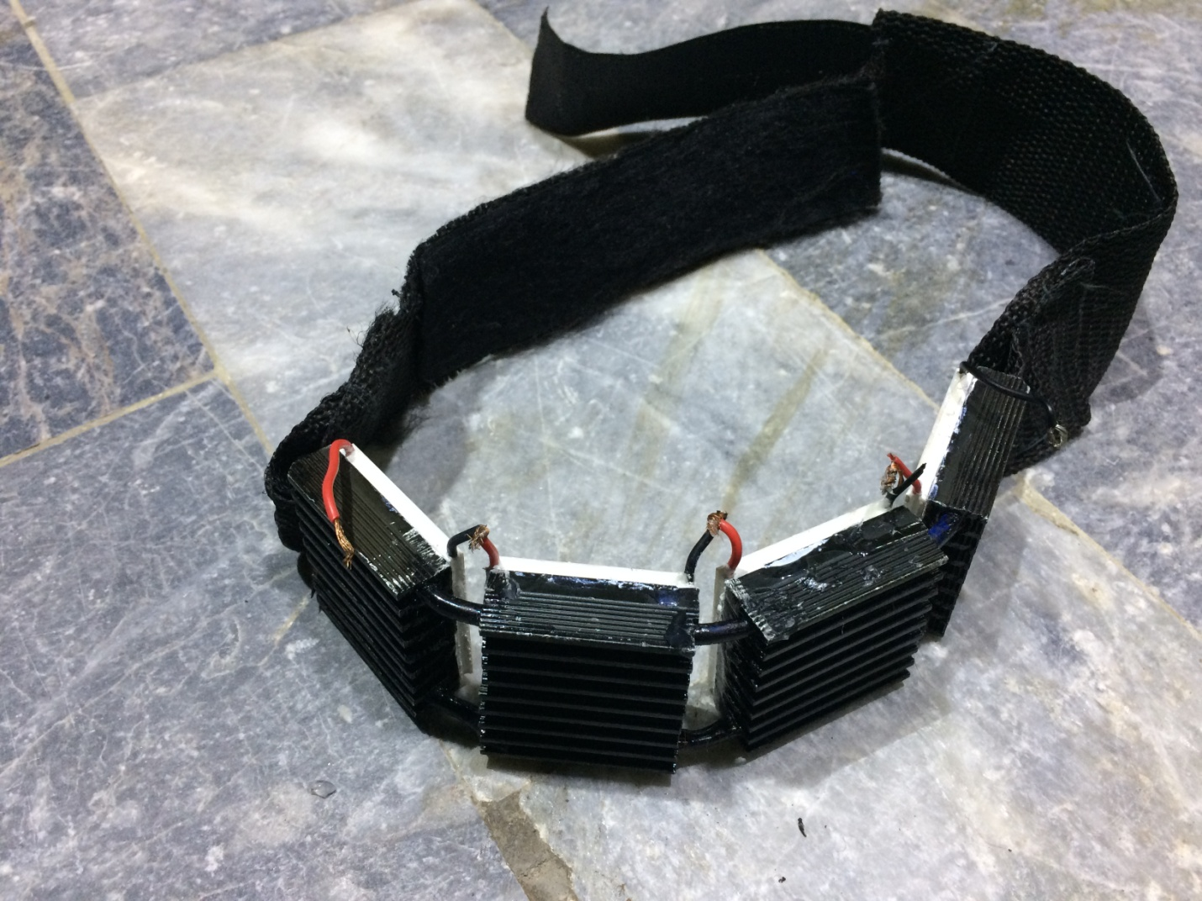

Increasing the remaining wires
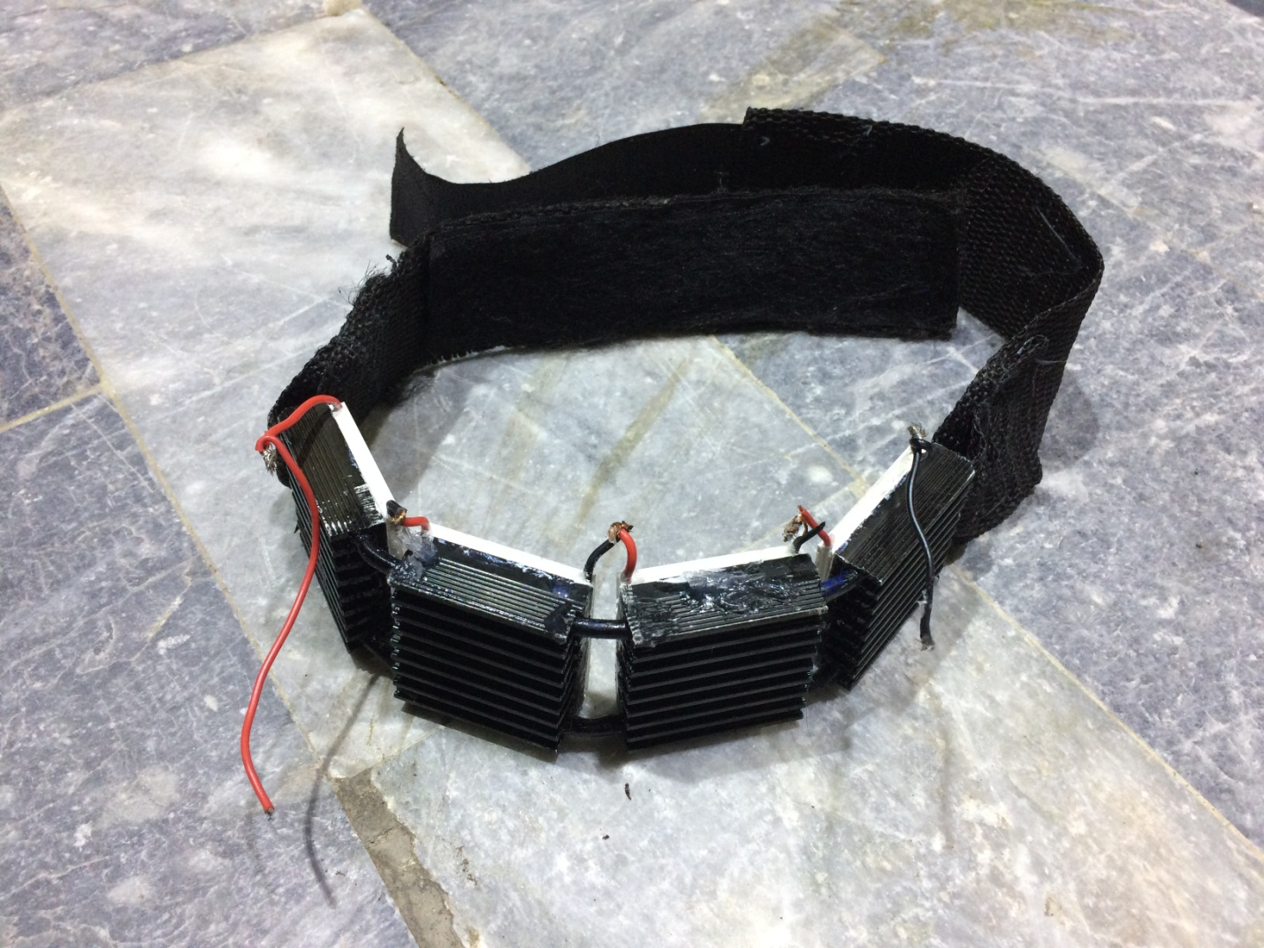

Connecting remaining wires with volt boosting circuit
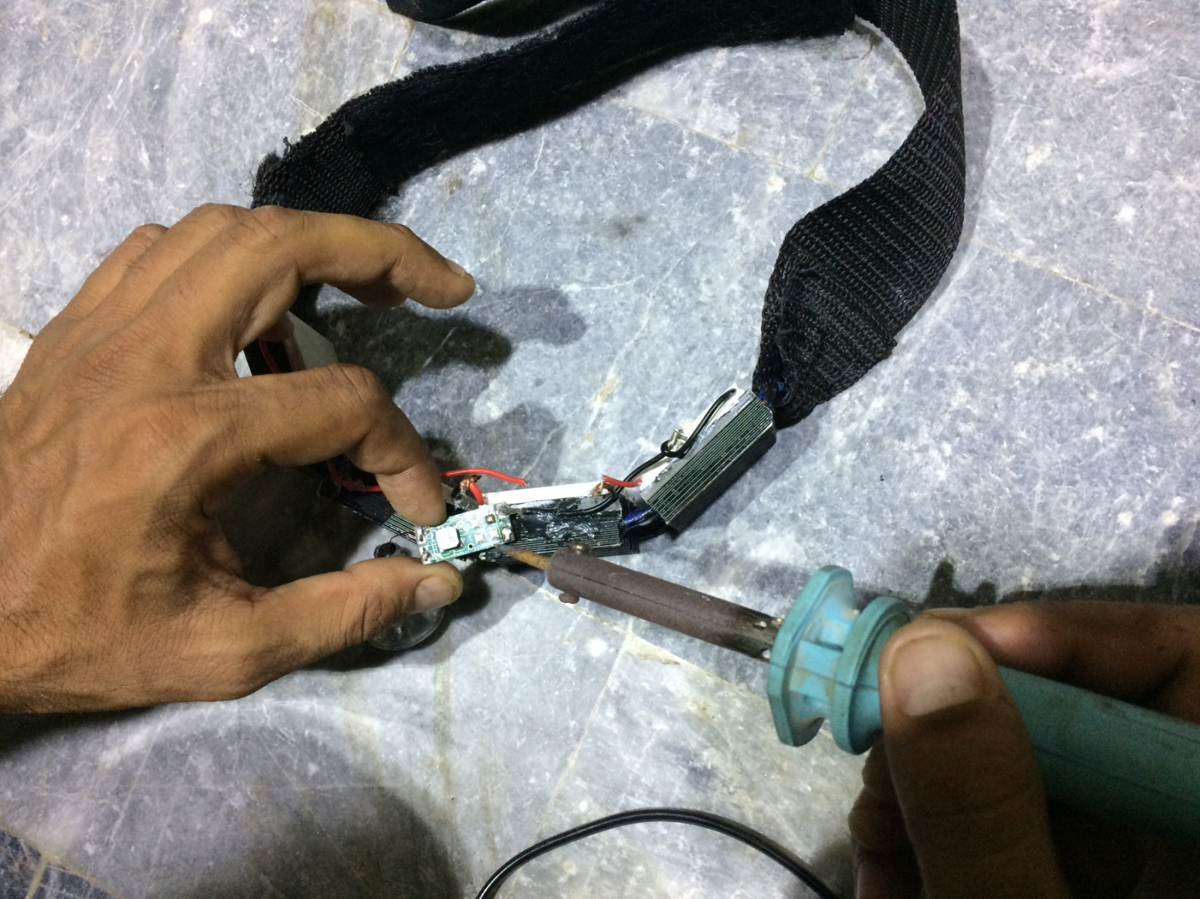

Final Result
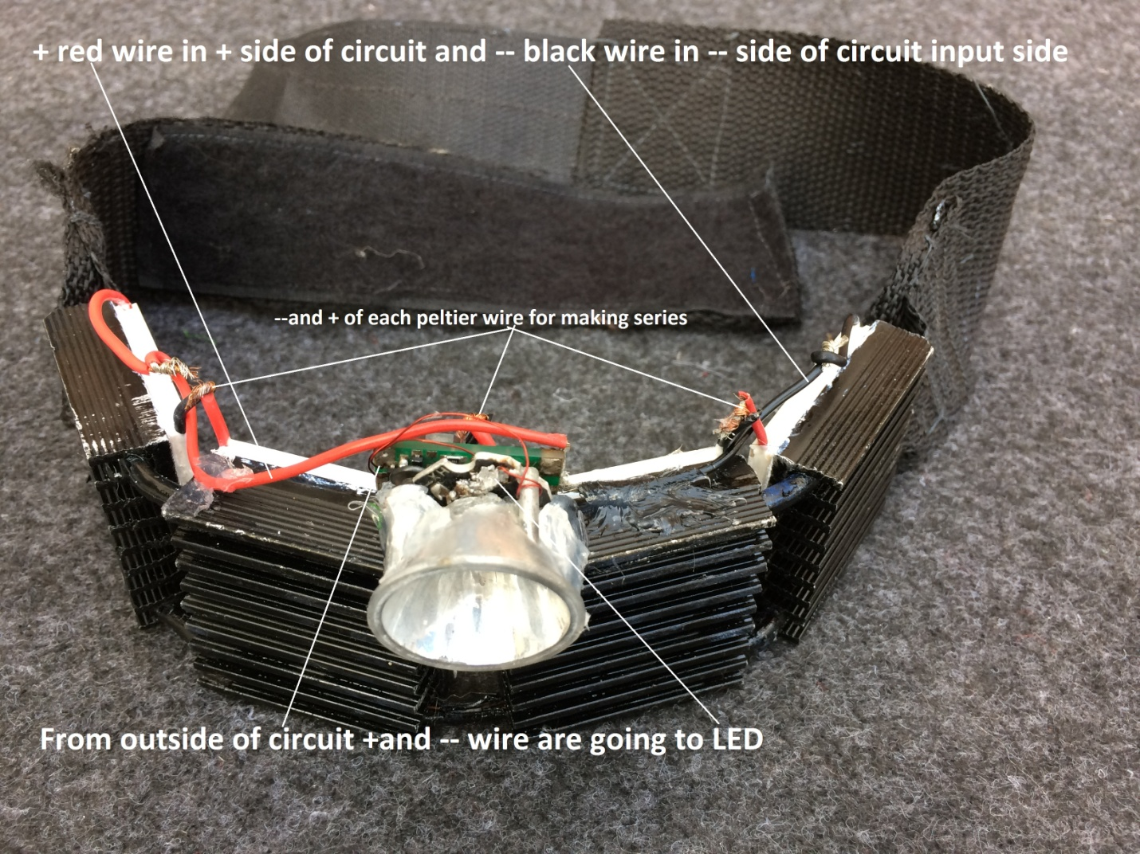

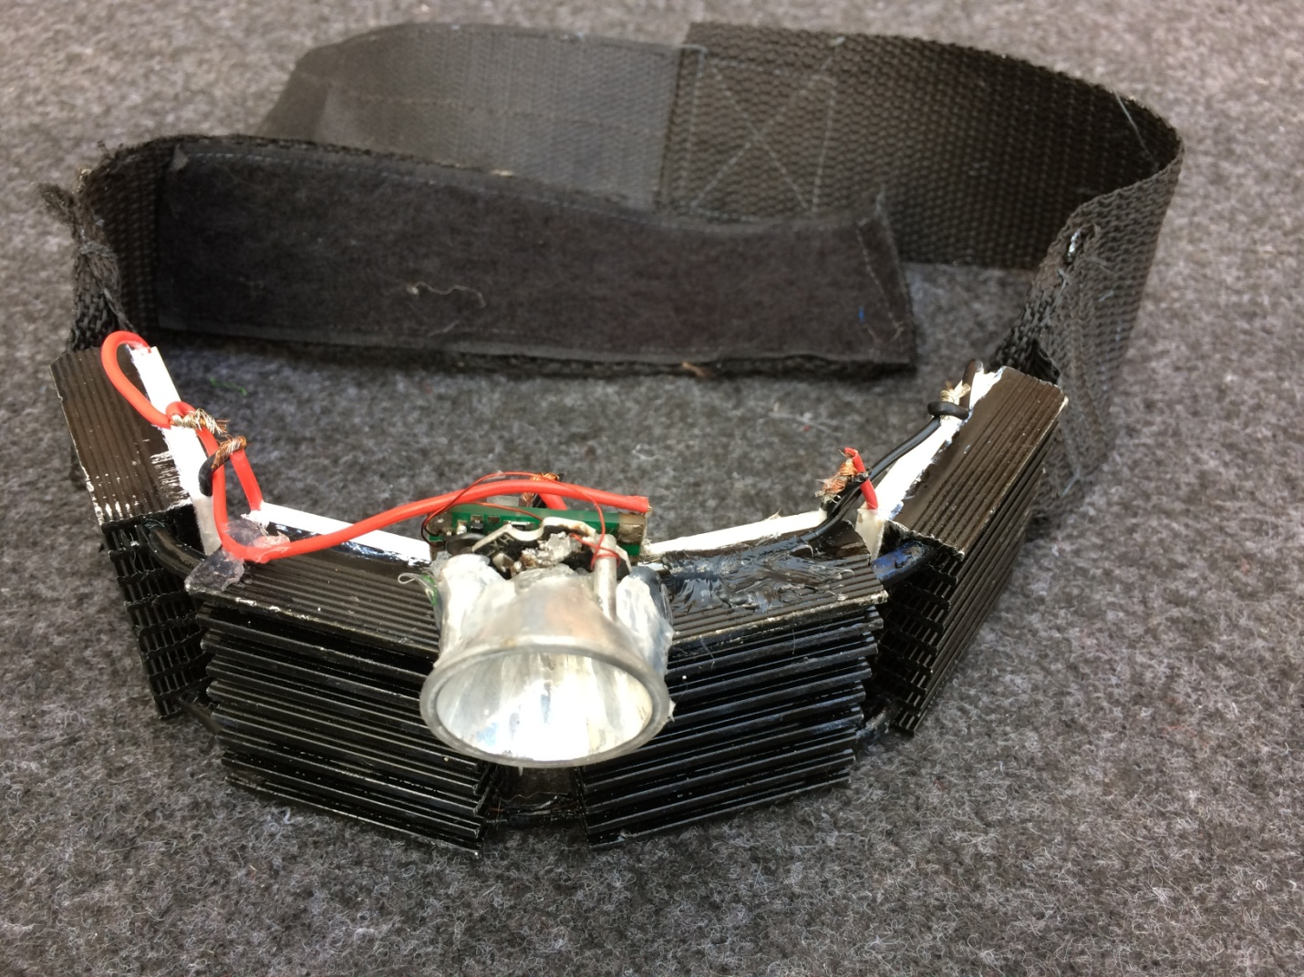
Thanks

